<!--This file created 2:29 PM 10/29/97 by Claris Home Page version 2.0-->4.4 Project
Making a Candy Box with Lid

A candy maker wants to package jelly beans in boxes each having a given fixed volume V. Each jelly bean box is to be an open-topped square-based rectangular box with base edge length x (Fig. 4.4.31). In addition, the box is also to have a square lid with a 2-in. rim. Thus the box-with-lid actually consists of two open-topped boxes — the 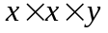 box itself with height 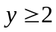 in., and the 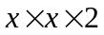 lid (which fits the box very snugly). Your job as the firm's designer is to determine the dimensions x and y that will minimize the total cost of the two open-topped boxes that comprise a single candy box with lid. Assume the box-with-lid is to be made using a nice foil-covered cardboard costing $1 per square foot, and that its volume is to be 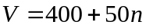 cubic inches. (For your personal design problem, pick an integer n between 1 and 10.

To illustrate your possible approach to this task, suppose the fixed volume of the box is V = 1000 cubic inches. This provides the relation

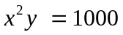 (1)

between the dimensions x and y of the box. The formula for the total area (= cost) to be minimized is

(2)

If we substitute y = 1000/x² from (1) into (2) and simplify, we get the function

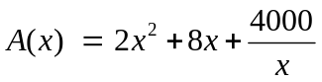 (3)

whose value we need to minimize on the interval 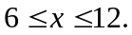 The graph below shows a single low point, with x apparently between 9 and 10.
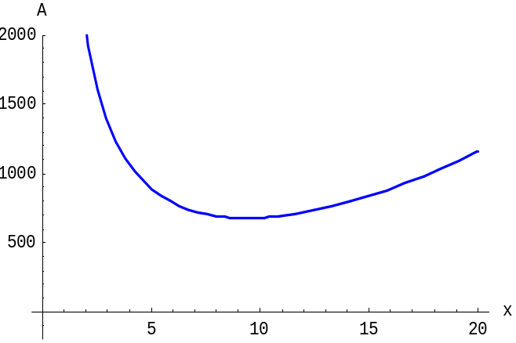
We could zoom in on the low point in this figure, but we know that it is where the tangent line to the graph is horizontal, and therefore where the derivative A' (x) vanishes,

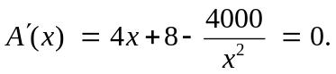 (4)

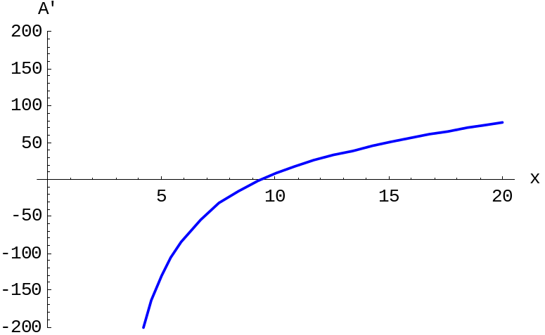

So instead we zoom in on the x-intercept of the graph of A' (x). After several zooms we get the following graph where we see that x = 9.376 accurate to 3 decimal places. Then (1) yields y = 1000/9.376² = 11.375. Thus our optimal candy-box-with-lid has dimensions 9.38" by 9.38" by 11.38".

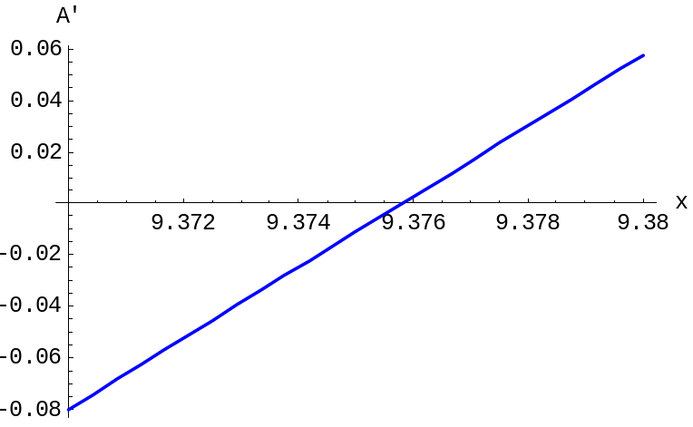

Alternatively, you could multiply Eq. (4) by x² and simplify to obtain the cubic equation
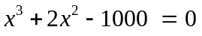 (5)

that can be solved either graphically or using a computer algebra system solve command.
The problem with a cylindrical box (instead of a rectangular one) follows the same pattern — after altering Eqs. (1) and (2) appropriately.

Using a Graphing Calculator
To solve graphically the equation in (3), we first define Y1=4+8-4000/X² and plot in the window 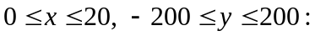

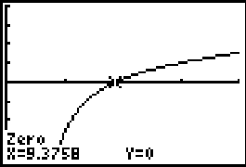

Here — in lieu of zooming — we have already used our calculator's Calc zero
facility to solve for x = 9.3758 as the solution accurate to 4 decimal places. It follows that y = 1000/9.3758² = 11.3758. Hence the optimal box-with-lid has dimensions
9.3758" by 9.3758" by 11.3758".
Alternatively, you can use the solve function that is is entered from the
calculator's CATALOG menu.

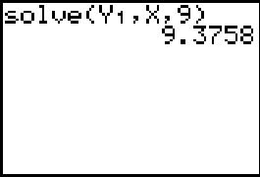

Here we've directed that the equation Y2 = 0 -- that is, A'(x) = 0 — be solved, starting with the initial guess x = 9.
Using Maple

We define the area function appearing in Eq. (3) above,

A := x -> 2*x^2 + 8*x + 4000/x:

and proceed to plot its derivative:

plot( D(A)(x), x=0..20, y=-200..200);

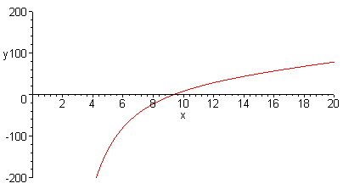

Spotting the apparent solution between x = 9 and x = 10 we proceed to solve numerically:

fsolve( D(A)(x) = 0, x, x=9..10);
9.375810570

Thus x = 9.3758 as the accurate to 4 decimal places. It follows that y = 1000/9.3758² = 11.3758. Hence the optimal box-with-lid has dimensions 9.3758" by 9.3758" by 11.3758".

Using Mathematica

We define the area function appearing in Eq. (3) above,

A[x_] := 2*x^2 + 8*x + 4000/x

and proceed to plot its derivative:

Plot[A'[x], {x, 0, 20}, PlotRange -> {-200,200}];

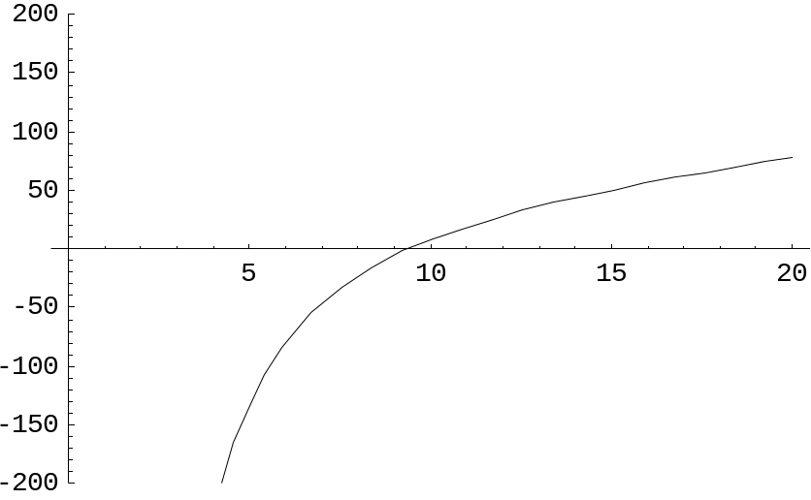
Spotting the apparent solution between x = 9 and x = 10 we proceed to solve numerically:

FindRoot[A'[x] == 0, {x, 9, 10}]
{x -> 9.37581}

Thus x = 9.3758 accurate to 4 decimal places. It follows that y = 1000/9.3758² = 11.3758. Hence the optimal box-with-lid has dimensions 9.3758" by 9.3758" by 11.3758".

Using MATLAB

We immediately plot the derivative function appearing in Eq. (4) above,

A := x -> 2*x^2 + 8*x + 4000/x:

and proceed to plot its derivative:

fplot('4*x+8-4000./(x.*2)', [0 20 -200 200])
grid on

Spotting (in the resulting figure shown on the next page) the apparent solution near x = 9, we proceed to solve numerically:

fzero('4*x+8-4000./(x.^2)',9)
ans =
9.3758

Thus x = 9.3758 accurate to 4 decimal places. It follows that y = 1000/9.3758² = 11.3758. Hence the optimal box-with-lid has dimensions 9.3758" by 9.3758" by 11.3758".

